**Note:**

**Tumhala jar user id ani password provide kela ter kara otherwise skip kara**

**Practical 10**

**Aim : Implementation of Openstack with user and private network creation.**

Step 1 : Open “ Open metal ” website .

Step 2 : Login with your id .

Step 3 : They’ll show you two options :- 1> Private cloud 2> Organizational cloud.

Step 4 : Click on Private cloud .

Step 5 : Select recommended server size which is giving you the 8 hours access. Complete the sign-in process carefully.

Your Open Stack cloud’s dashboard will look like this:

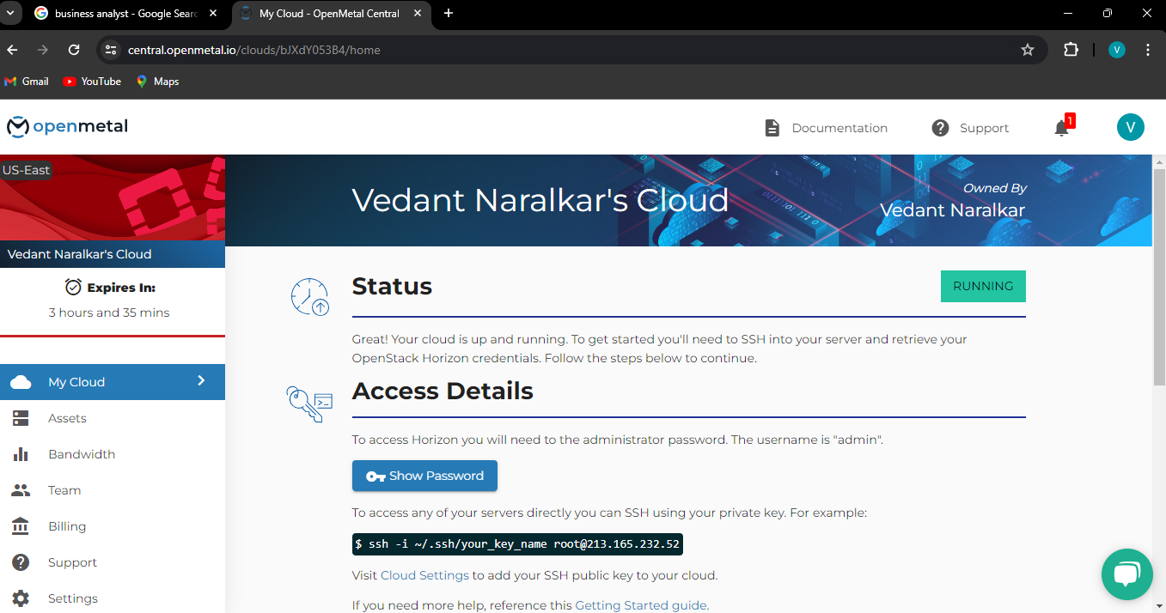

Step 6 : You have to setup your horizon .

Step 7 : So click on Launch horizon button as shown below.

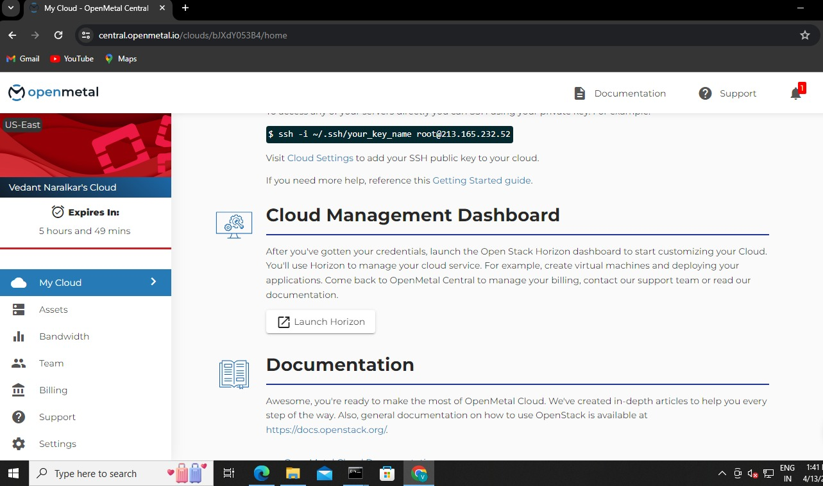

Step 8 : They’ll ask you username and password .

Step 9 : Give username “admin” and password which is mentioned in the Show password button.

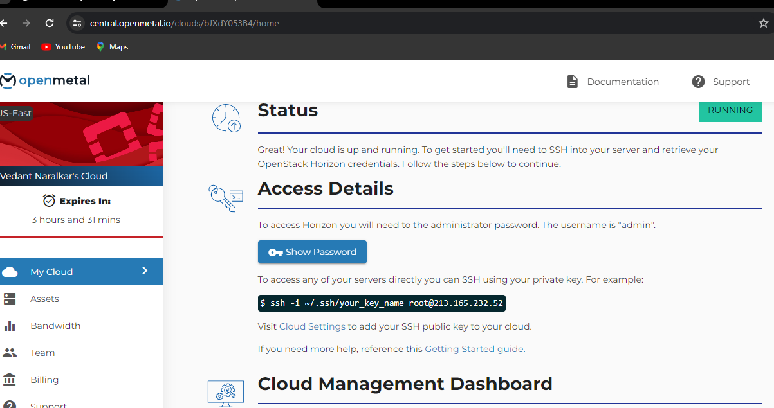

Step 10 : After sign in , you’ll see your horizon dashboard which is your main dashboard.

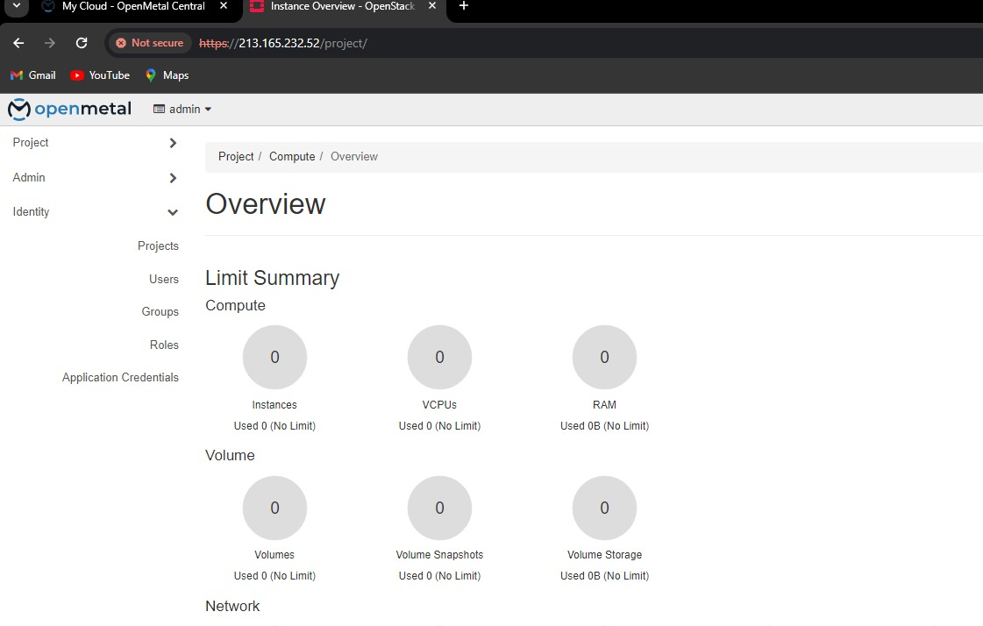

Step 11 : First we need to create a project .

Step 12 : Click on Identity on the left side.

Step 13 : Then click on Projects . It’ll show you some default projects the system .

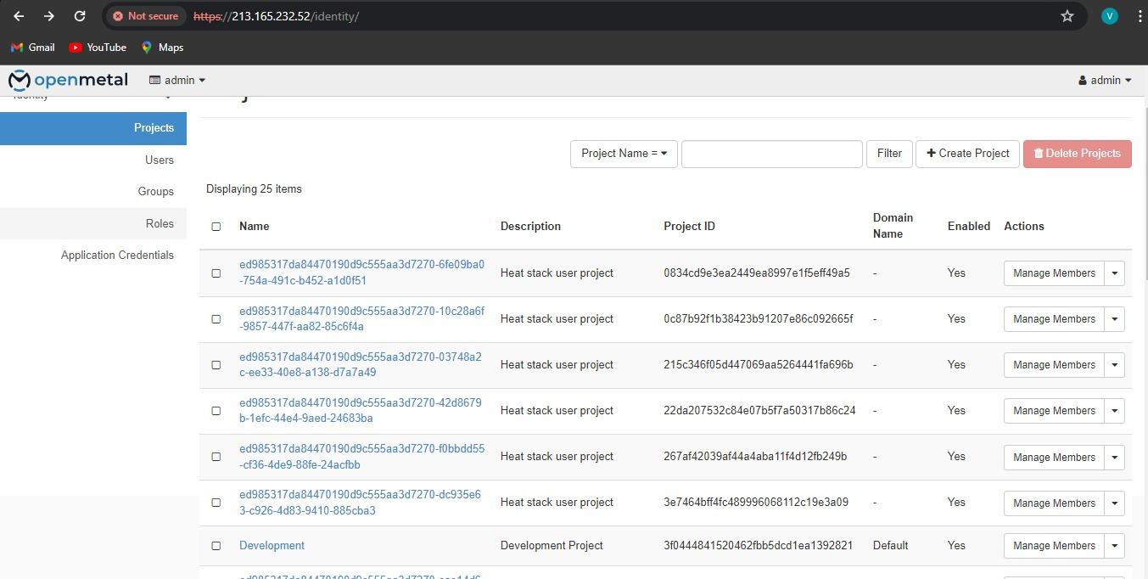

Step 14 : Click on create project .

Step 15 : Fill any random details . for ex – as show below.

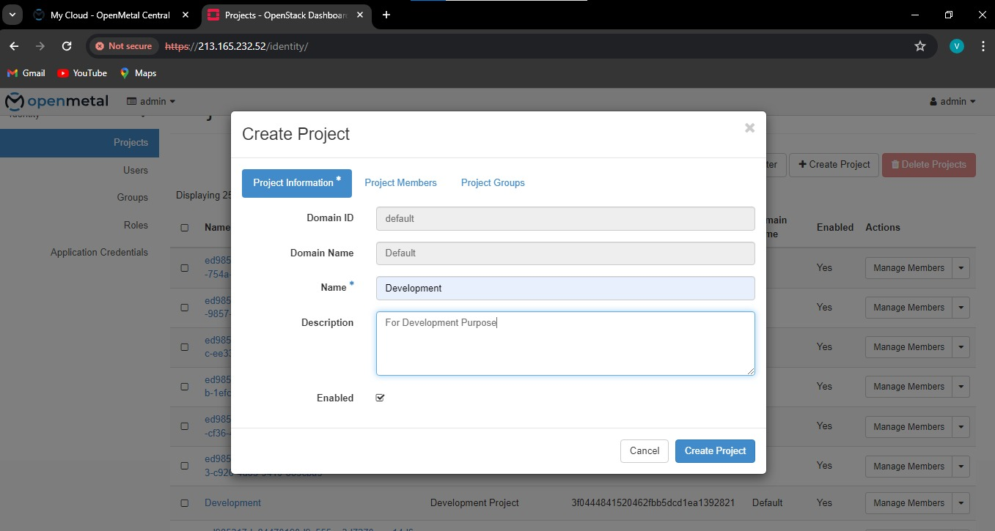

Step 16 : Click on create Project.

Step 17 : After successfully creating project.

Step 18 : Click on users in the Identity Tab. It’ll show you some default users.

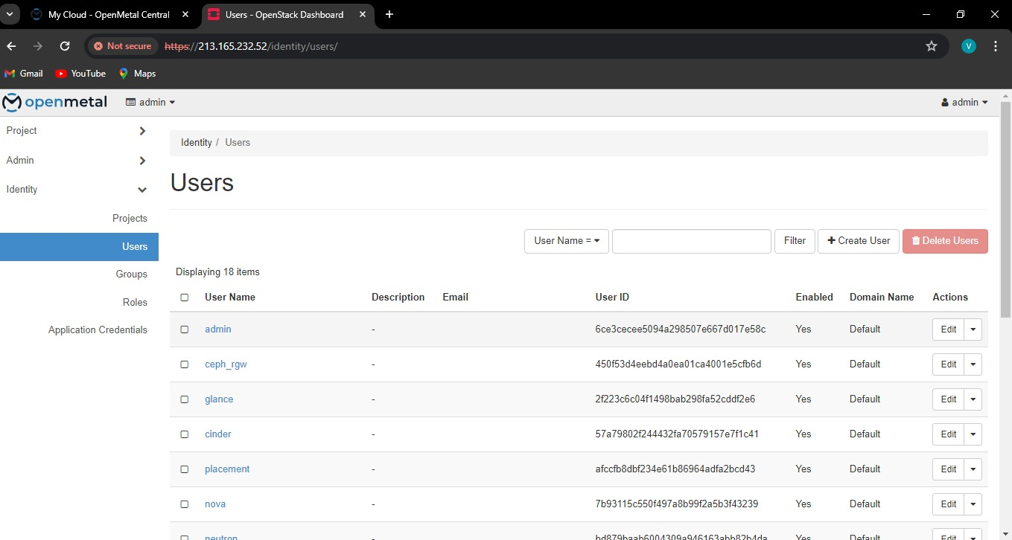

Step 19 : Click on create user.

Step 20 : Fill the info given in the form like your username , email , set your password ,

Select the project you’ve currently created as your primary project and select member as a role.

Step 21 : Click on create user button.

Step 22 : It’ll show you user you created in the list .

Step 23 : Sign out as admin user.

Step 24 : And sign in again as the user you have created not the admin username and password. For ex –

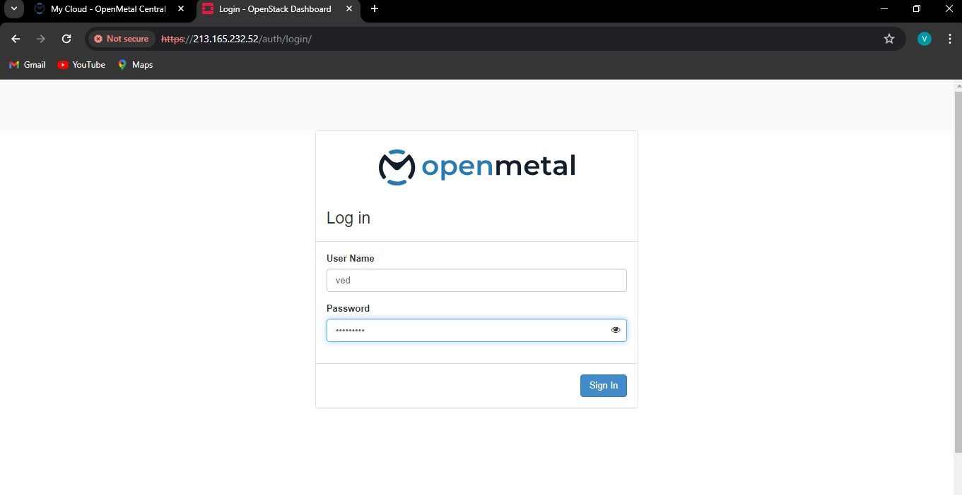

Step 25 : Click on Projects.

Step 26 : Click on Network and the click on networks.

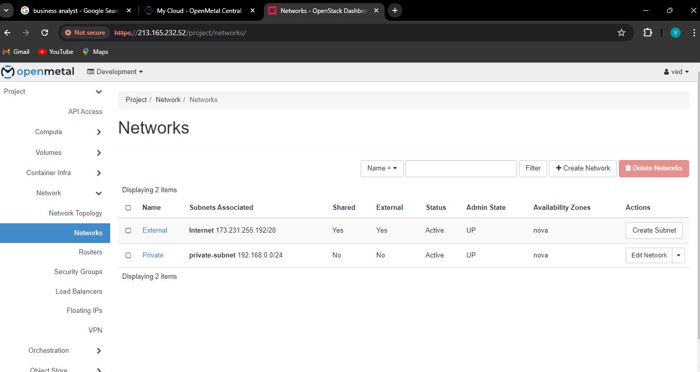

Step 27 : To create your new private network , click on Create network button.

Step 28 : Fill info as shown below.

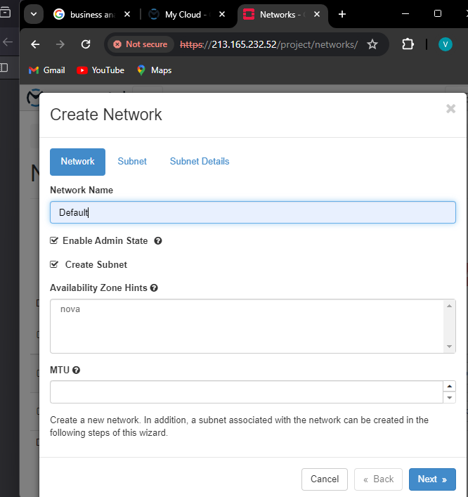

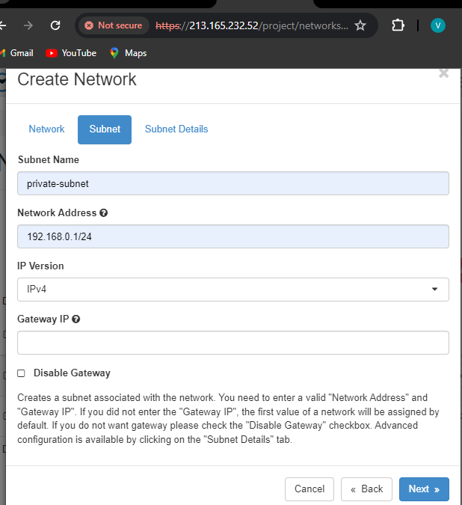

Step 29 : Click on next.

Step 30 : After successful network creation , you’ll see default network created as shown below.



Step 31 : Click on Routers in the left side.

Step 32 : Click on Create Router .

Step 33 : Fill info as shown below.

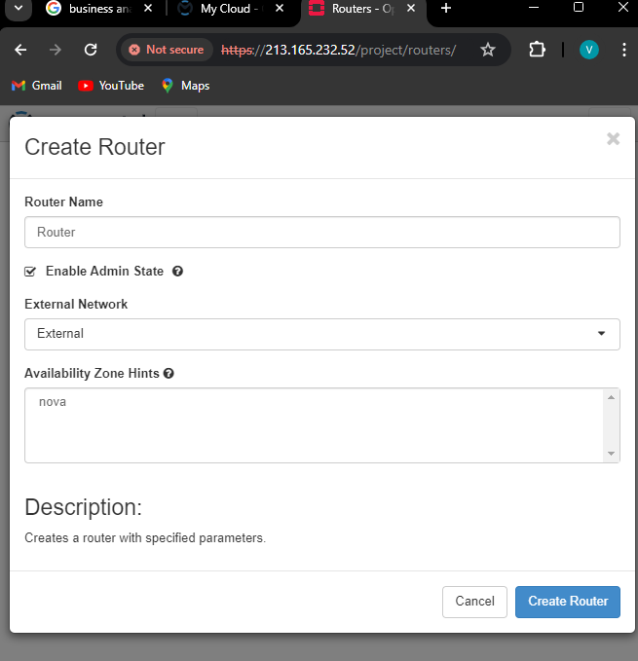

Step 34 : Click on Create router .

Step 35 : It’ll show you the Router created successfully.

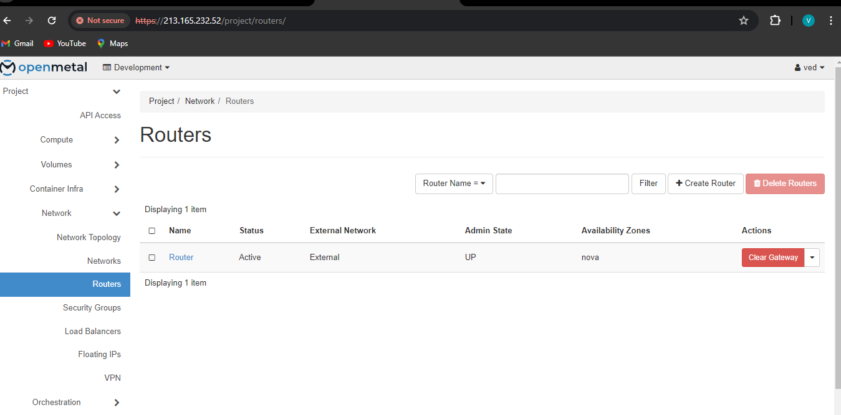

**So like this your private network in Openstack has successfully created with your specific user.**